SUPPORTING DOCUMENTS  Computer Professionals, Inc. | Document Code : TM-GW-GD-05
Section: 20.0 GENIISYS Web Development and Support | Revision No.: 0 | Page 1 of 8
Title : Scope of Work and Resource Loading | Effective Date: March 17, 2016

Note: Include this page only when adding / amending / deleting a document. If using this document as a record, this Revision History page can be omitted.

REVISION HISTORY
Revision no | Date | Description of Changes | Reason for Revision | Revised by | Approved by
0 | 17 Mar 16 | Initial check-in |  | GCMiralles | RCGanal
TM-BR-MG- 11 Rev02, 10302015

- SCOPE OF WORK

DESCRIPTION |  | ENHANCEMENT DETAILS
< object name> | <object description> | <details>
<module id> | <module description> | <details>
<report id> | <report description | <details>
For small enhancement, you may provide images

Example

DESCRIPTION |  | ENHANCEMENT DETAILS
P_UWREPORTS | Database package | Computation…..
GIPIS111 | View policy info | Inquiry screen to display…… Please refer to figure A
GIACR111 | Report | Add columns for …..

Figure A

- SCHEDULE (Example)

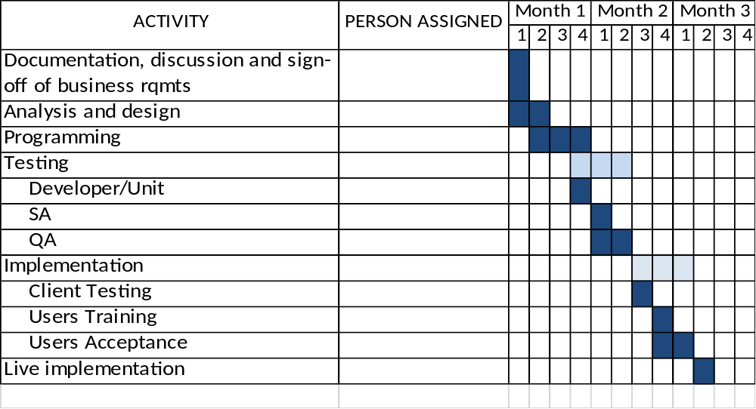

- RESOURCE LOADING (example)

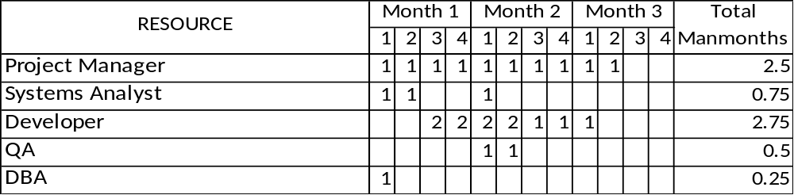

- OUT OF SCOPE
Please indicate the limitations that are not included in the design and feature

- REQUIREMENTS
Below are some examples:
  - Signed and final copy of the enhancement details
  - Pre-printed forms to be used in test printing.
  - Database structure for testing environment

